**Lab 7**

1. **Implementation of linear regression in Tensorflow using Boston Dataset.**

For this task linear regression was implemented using given dataset. Dataset was divided into training and testing data.

Output:

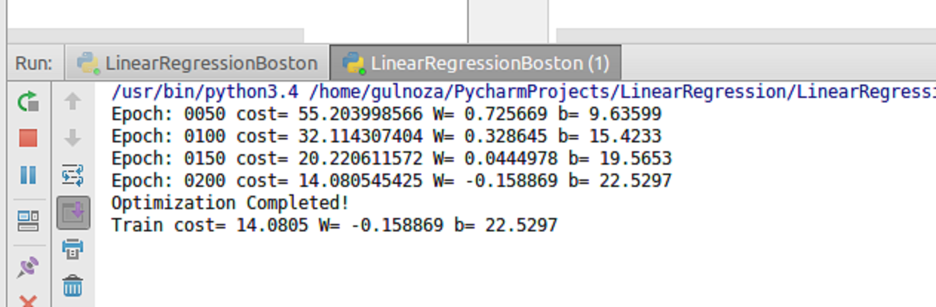

1. **Plot training cost using Matplotlib in python.**

Matplotlib was used to plot training cost.

Output:

